Definition List

# Program 1:

<html>

<head>

    <title>work23</title>

</head>

<body>

    <dl>

        <dt>Coffee</dt>

        <dd>Black hot drink</dd>

        <dt>Milk</dt>

        <dd>White cold drink</dd>

      </dl>

    <dl>

        <dt>HTML</dt>

        <dd>is a markup language</dd>

        <dt>Java</dt>

        <dd>is a programming language and platform</dd>

        <dt>JavaScript</dt>

        <dd>is a scripting language</dd>

        <dt>SQL</dt>

        <dd>is a query language</dd>

    </dl>

</body>

</html>

# OutPut :

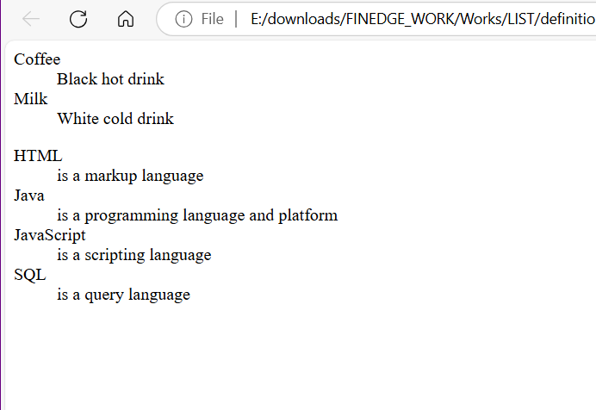

# Program 2 :

<!DOCTYPE html>

<html lang="en">

<head>

    <meta charset="UTF-8">

    <meta name="viewport" content="width=device-width, initial-scale=1.0">

    <title>Nested Definition List</title>

</head>

<body>

    <h2>Programming Languages</h2>

    <dl>

        <dt>Frontend</dt>

        <dd>

            <dl>

                <dt>HTML</dt>

                <dd>Markup language for structuring web pages.</dd>

                <dt>CSS</dt>

                <dd>Used for styling web pages.</dd>

            </dl>

        </dd>

        <dt>Backend</dt>

        <dd>

            <dl>

                <dt>Python</dt>

                <dd>A general-purpose, high-level programming language.</dd>

                <dt>Java</dt>

                <dd>A robust language used for backend development.</dd>

            </dl>

        </dd>

    </dl>

</body>

</html>

# OutPut :

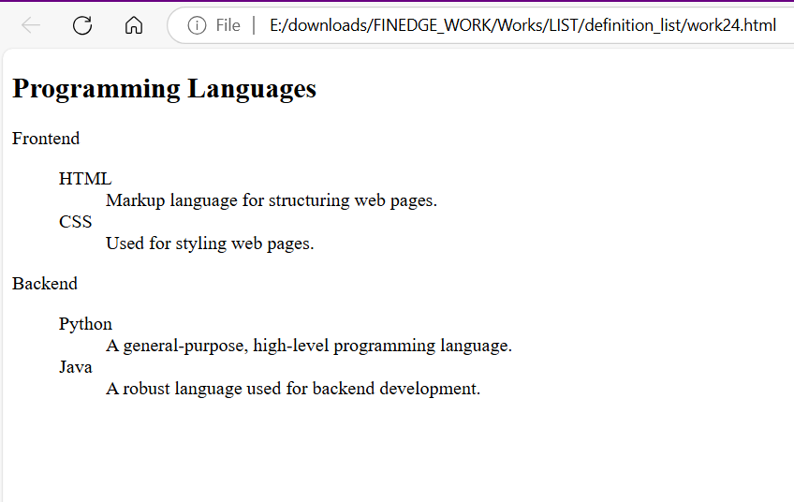

# Program 3 :

<!DOCTYPE html>

<html lang="en">

<head>

    <meta charset="UTF-8">

    <meta name="viewport" content="width=device-width, initial-scale=1.0">

    <title>Basic Definition List</title>

</head>

<body>

    <h2>Fruits and Their Descriptions</h2>

    <dl>

        <dt>Apple</dt>

        <dd>A sweet fruit that comes in red, green, and yellow colors.</dd>

        <dt>Banana</dt>

        <dd>A soft, tropical fruit rich in potassium.</dd>

        <dt>Cherry</dt>

        <dd>A small, round fruit with a pit inside.</dd>

    </dl>

</body>

</html>

# OutPut :

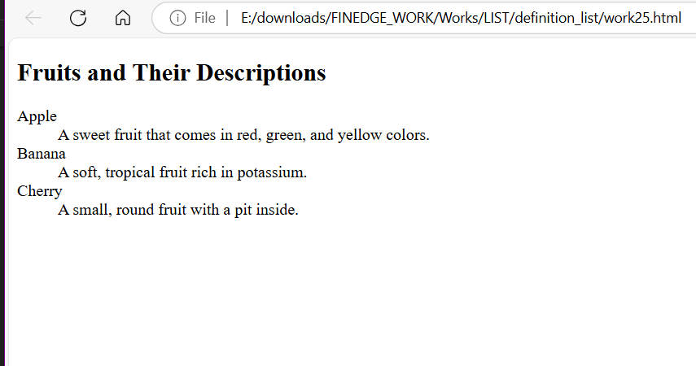

# Program 4 :

<!DOCTYPE html>

<html lang="en">

<head>

    <meta charset="UTF-8">

    <meta name="viewport" content="width=device-width, initial-scale=1.0">

    <title>Multiple Descriptions Example</title>

</head>

<body>

    <h2>Technology Terms</h2>

    <dl>

        <dt>AI</dt>

        <dd>Artificial Intelligence.</dd>

        <dd>The simulation of human intelligence in machines.</dd>

        <dt>API</dt>

        <dd>Application Programming Interface.</dd>

        <dd>A set of functions for building software applications.</dd>

    </dl>

</body>

</html>

# OutPut :

